**How to save work on J2 write**

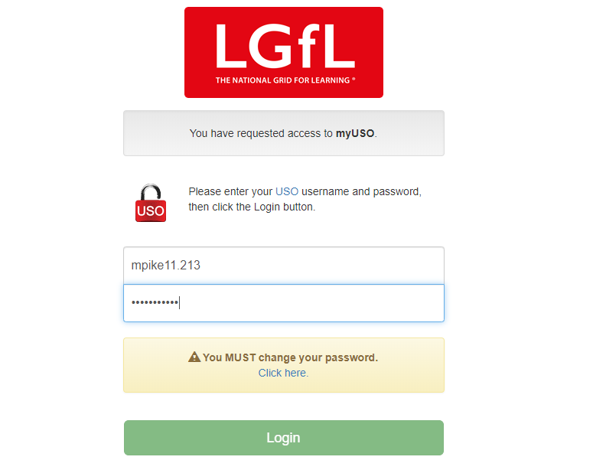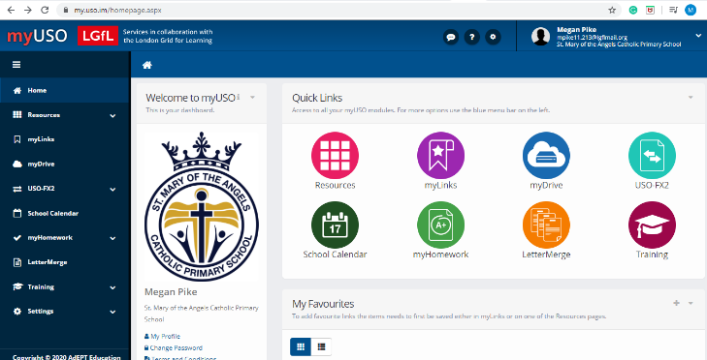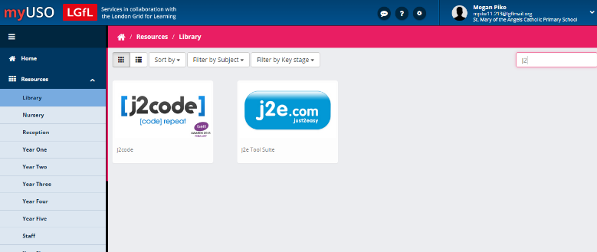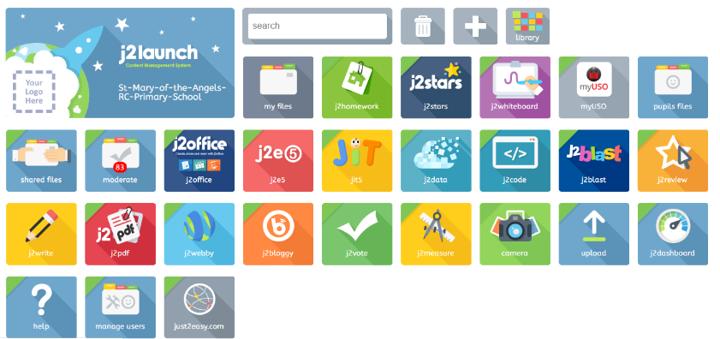

Make sure you login using the USO Login, the Easy Login option will only work at school. You can find this login in your reading record or home learning pack.

This will take you to this screen where you can login to get access to lots of amazing resources.

This will take you to this screen that looks similar to this. Yours might look slightly different but you should still be able to click on resources.

Search for j2e.com using the search bar.

This will take you to this screen which has lots of useful tools for doing your work online. To create a work document that I will be able to see click on j2e5

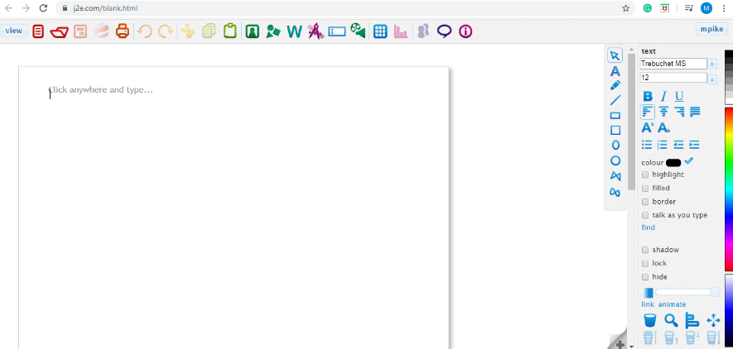

Then you can create your work. Once you have finished your work then click the save button. This will save your work to your files. Once you have done this I will be able to see your work as well.

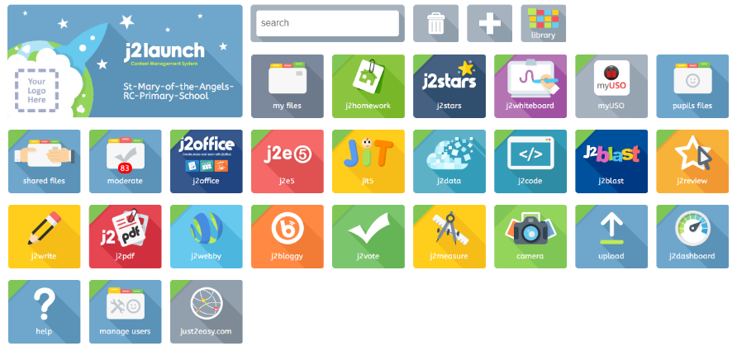

Once you have saved your documents you can find them all in my files. Remember to keep saving your work as you go.

f

You should be able to use this handy tool on a laptop, I Pad and smart phones. I look forward to seeing all of the fantastic work that you create whilst working at home!