Foundation Stage Activities
Maths
Reception | Nursery
Practice writing your numbers to 20 | Practice writing your numbers to 5
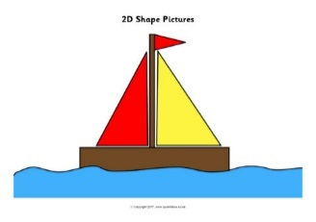
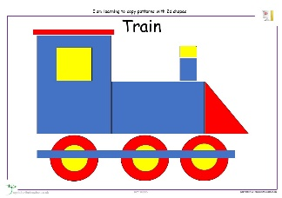
Using 2D shapes make a picture of a house/rocket/castle etc.

English
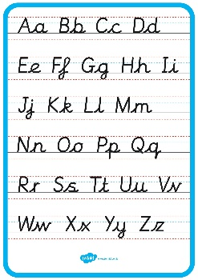
Write your capital and small letters
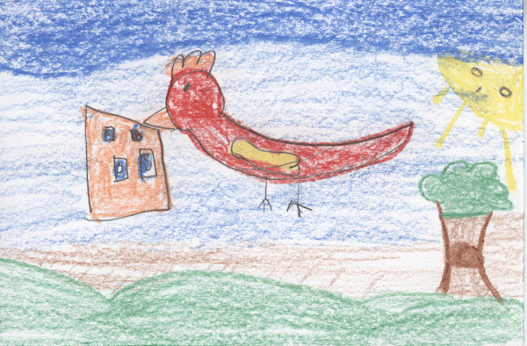
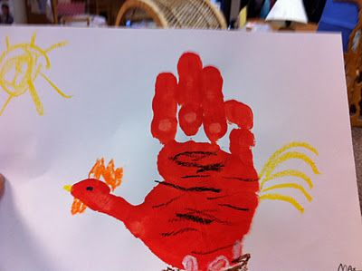
Draw a picture of The Little Red Hen
Write a sentence about the little red hen.
e.g. Not I said the cat.
Not I said the dog.
The Little red Hen collected the wheat.
Or
Label your picture.
Revise the sounds that have been learnt so far in their Jolly Phonics learning books. | Complete the phonics sheets that have been sent home.
Science
Draw a picture of a plant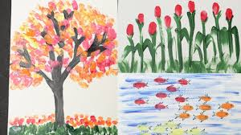
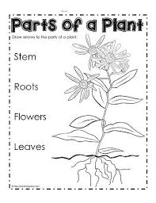
Label the parts of the plant
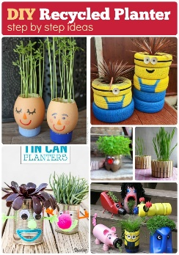
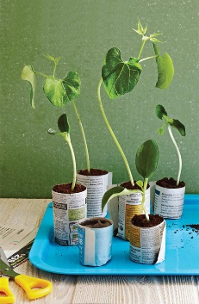
Plant some seeds using recycled materials. E.g. yoghurt pots
RE
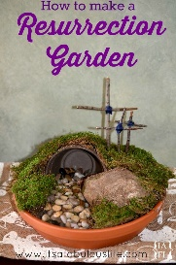
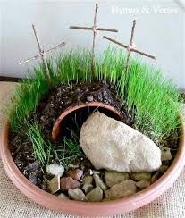
Make an Easter Garden
Take a photo of your child fufilling their Lentern promise.
Art and Design
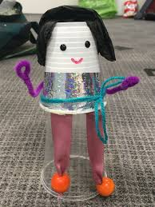
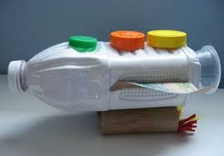
Recycling – Junk Modelling. Can you make a robot/rocket/house using junk around the house?
Reading
Read with your parent/carer everyday.
Practice your sounds and tricky words.

