Websites that offer learning opportunities and resources

Name of website | Link | Brief description of activities | Age range | Logo
General
TTS | https://www.tts-group.co.uk/home+learning+activities.html | Downloadable workbooks. The books contain work from all different subject areas. | KS1book  KS2 book  EYFS book (not ready yet).
Bug Club/ Phonics/Spelling and Grammar | https://www.activelearnprimary.co.uk/login?c=0 | Our chosen reading scheme is Bug Club, a finely levelled, phonically based reading scheme, which ensures that each child can find a book at exactly the right level for them. Alongside reading books, your child will be allocated a range of phonics/spelling and grammar activities. | EYFS  KS1  KS2
Oxford Owl for Home | https://www.oxfordowl.co.uk/for-home/ | Free eBook collection, developed for children aged 3–11 years old. Oxford Owl is offering free access for parents at this time. You just need to register-follow the link. | EYFS  KS1  KS2 | 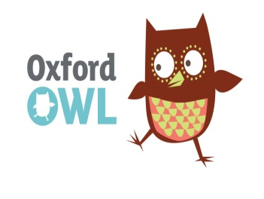
The Spelling and Maths Shed | https://www.spellingshed.com/en-gb | Spelling Shed and Maths Shed.  Spellings (for Years 3 - 6) will be updated weekly on spelling shed. It would be great if parents could test children weekly on their spelling words (we usually test on Fridays). We highly recommend 20 to 30 minutes a day on spelling shed or practising spellings using the tips in the guidebooks. We've also added all the spelling lists (which we cover across the year) to spelling shed so pupils can revise spellings from earlier in the year. Free to parents at our school. | KS1  KS2 | 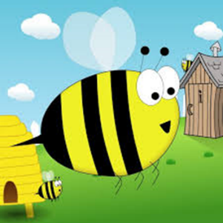
Audible is an online audio book library | https://stories.audible.com/start-listen | Audible is an online audio book library. You can download books for children to listen to. They have made many of their stories free for children at the moment. | EYFS  KS1  KS2
Twinkl | www.twinkl.co.uk/offer  Enter the code  ZAFTWINKLHELPS or  UKTWINKLHELPS | Twinkl offers a range of resources for all subjects. They are offering free access for parents at this time.  Unlimited access for 1 month. | EYFS  KS1  KS2
Classroom magazines Scholastic | https://classroommagazines.scholastic.com/support/learnathome.html | Every day they put up activities, videos and projects suitable for each age group. We recommend that you use a supported browser such as Chrome, Firefox, Safari, or Edge to use this program. | EYFS  KS1  KS2
BBC Newsround | https://www.bbc.co.uk/newsround | Newsround, games, quizzes, puzzles | KS1  KS2
First News | https://subscribe.firstnews.co.uk/free-downloadable-issue/ | First News is a weekly newspaper aimed at 7 to 14-year-olds that aims to get kids talking about the news. Inside you’ll find a mix of world and UK news, as well as fun games and puzzles.  Free access for a limited time to help parents and children during school closures. | KS1  KS2
Cbeebies Radio/ educational shows | https://www.bbc.co.uk/cbeebies/radio | CBeebies has content that is specifically produced for a younger audience - at a pace and style that suits them. | EYFS  KS1 | 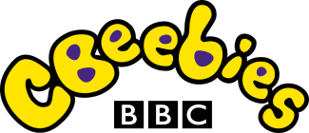
Classroom secrets | https://classroomsecrets.co.uk/free-home-learning-packs/?goal=0_9fbcd14815-2bec22d22d-191422187 | A range of activities covering a range of subjects | EYFS  KS1  KS2
My Daily Diary - by Harold | https://www.coramlifeeducation.org.uk/harolds-daily-diary | My Daily Diary - by Harold  Each day he’ll be giving children positive, fun messages about what he’s doing to stay happy and healthy while he’s off school, separated from his friends. He’ll invite the children to join in with activities he’s doing. | EYFS  KS1  KS2 | 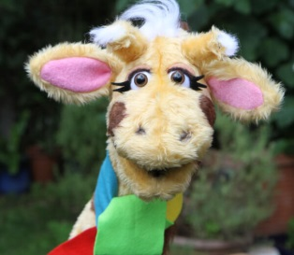
Educational Games
Top Mark | https://www.topmarks.co.uk/ | A range of interactive games covering all subjects | EYFS  KS1  KS2
ICT Games | https://www.ictgames.com/ | English and Maths games. Tablet and desktop friendly. Free educational games aimed at children between 5 and 8 years old. | EYFS  KS1  KS2
Instagram/Facebook Reading Events
Mac Barnett | https://www.instagram.com/macbarnett/?hl=en | Mac Barnett is going LIVE on Instagram, EVERY DAY @ 3:00! He plans to read through ALL of his books! Enjoy! | EYFS  KS1
Oliver Jeffers | https://www.facebook.com/oliverjeffersart/?__xts__[0]=68.ARAFTOwBU5_6xV67nt6OuPLTOGrAMAH5vECDQR1aa-_V1DHTsdZha4BcKZo353HLRnY4BOe2PJGTZQKosOJcERsdDEGB_jWvsr7K2YE6UBV5F4hwrgykZkSFyFIQCDZ6IWpQ3d0RCuIXUk3ejBslgwKdNV3Sih93Awq56n7d5XcJVO6Wzq2My1SK1yRdOSmvb4h5ZaG9ft6m73C0hV9gULKVMLTGe-dPLzi34furSKLwt_l2vcxIrwszehY0SMHIlT3nJzZmPMrYvCDS81gLCt1zeBe7CjvdDrqFdvB9VIRHFmjWpzJZ_64h6ZfXHzDp7J5M7JW5_RY-DpKo&__tn__=k*F&tn-str=k*F | Oliver Jeffers will be reading one of his books every weekday, and talking about some of the things that went into making it. | All ages | 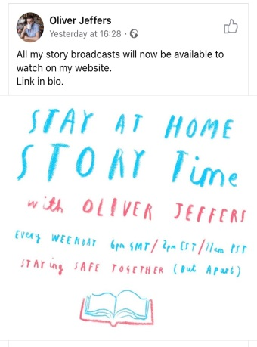
David Walliams | https://www.worldofdavidwalliams.com/elevenses/ | David Walliams reads audio books.  David Walliams (and friends) will be reading stories every day at 11am. Free | All ages
Josh Gads | @joshgad on twitter | Josh Gads (who is the voice of Olaf) is reading a story a day on his twitter page. Goggle Josh Gads Twitter. Free | All ages
English Story Starters
Pobble 365 | http://www.pobble365.com/ | English, writing stimuli, grammar work etc  One picture. One teaching resource. Every day. | Year 3- Year 6
Once Upon a Picture | https://www.onceuponapicture.co.uk/ | English writing stimuli using images.  Writing ideas for all age groups. | KS1  KS2
Maths
White Rose Maths | https://whiterosemaths.com/homelearning/ | White Rose Maths Team has prepared a series of five maths lessons for each year group from Year 1-8. We will be adding five more each week for the next few weeks. Every lesson comes with a short video showing you clearly and simply how to help your child to complete the activity successfully. | EYFS (coming soon)  KS1  KS2
Mathletics | https://login.mathletics.com/ | All children have a login to this website. | EYFS  KS1  KS2 | 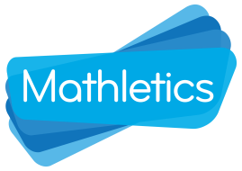
Maths with mum | https://www.mathswithmum.com/ | Maths with Mum is a free primary Maths course for parents and children.  We are continually producing new video lessons which break down concepts into small and easy-to-follow steps. We provide clear explanations to help your child to build a strong understanding of Mathematics. | KS1  KS2 | 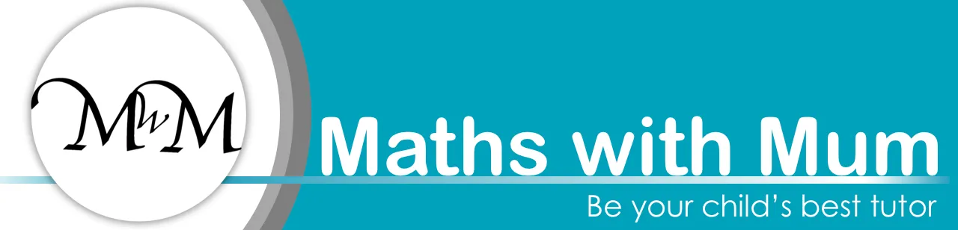
Prodigy | https://www.prodigygame.com/ | Sign up for a free account. Students learn Maths as they play as a creature from another realm and go through another world collecting gems. | KS1  KS2
Science
Edinburgh Zoo | https://www.edinburghzoo.org.uk/webcams/panda-cam/ | Edinburgh Zoo – Live Cameras where you can choose to view the Rockhopper Penguins, Pandas, Tigers or Koalas. Follow the Link for the camera you want. Free | EYFS  KS1  KS2
Wow Science | https://wowscience.co.uk/ | It has lots of topic based activities and games that are free to use and access. You can watch videos and experiments and play games. There are fun quizzes and it is interactive and engaging. | KS1  KS2
ESA kids | https://www.esa.int/kids/en/home  http://www.esa.int/kids/en/learn  http://www.esa.int/kids/en/things_to_do | The European Space Agency for kids have resources, news, information, animations and competitions for children to do related to space. | KS1  KS2 | 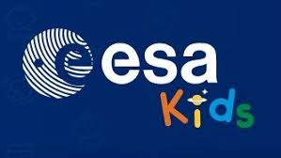
BBC bitesize  Terrific scientific- BBC teach | https://www.bbc.co.uk/bitesize/subjects/z2pfb9q  https://www.bbc.co.uk/teach/terrific-scientific  https://www.bbc.co.uk/programmes/articles/D11WHF8nc7QYqJ3RRG39dz/terrific-scientific-live-lesson | Fun games and interactive resources for all the different science topics. You can watch live lessons and experiments. | KS1  KS2 | 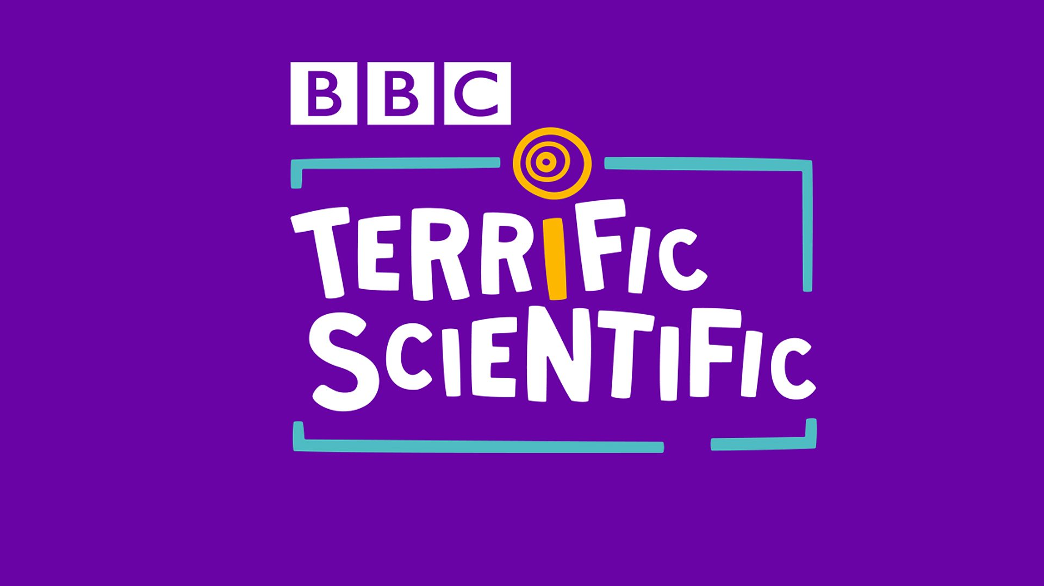
Discovering Antarctica | https://discoveringantarctica.org.uk/introducing-antarctica/ | Antarctica is a frozen, windswept continent, so hostile and remote that it has no permanent inhabitants. Scientists working here have made many discoveries from studying  This award-winning site contains resources for all age groups. | KS2
Science Sparks | https://www.science-sparks.com/category/primary-science/key-stage-1-science/ | Fun experiments to try at home. | EYFS  KS1  KS2 | 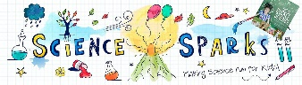
Computing
Dance Mat | https://www.dancemattypingguide.com/dance-mat-typing-level-1/stage-1/ | Touch typing programme | KS1  KS2
Scratch | https://scratch.mit.edu/ | Coding- a free programming website for children 8yrs+ | KS1  KS2 | 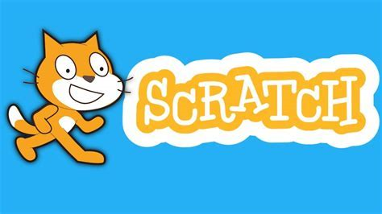
Scratch Jr | http://scratchjr.org | Coding  A more simplified version of Scratch for younger children (5-7yrs) | EYFS  KS1 | 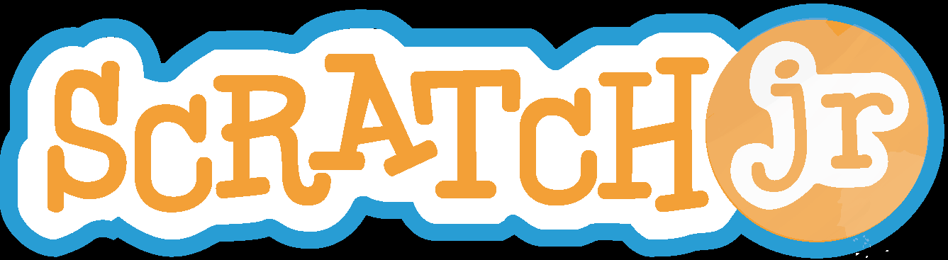
BBC Bitesize | https://www.bbc.co.uk/bitesize/subjects/zvnrq6f | Computing science, digital literacy and information technology. Would you like to learn about how search engines work or what makes a computer game?  This website shows you how to design your own app and create your own video. | KS2
Code | https://code.org/  https://studio.code.org/courses | Learn to code. Free tutorials for children. | EYFS  KS1  KS2
PE
Go Noodle | https://family.gonoodle.com/ | Exercise videos | EYFS  KS1  KS2 | 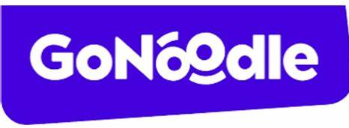
The imovement | https://imoves.com/imovement-signup | Keep the kids moving every day, we want to support you to get your children active!  That's why the imovement is FREE for teachers and parents! | EYFS  KS1  KS2
Joe Wick’s Daily PE Lesson | https://www.facebook.com/JoeWicksTheBodyCoach  https://www.youtube.com/thebodycoachtv | Joe Wick’s Daily PE lessons – 9am daily Free | EYFS  KS1  KS2
Geography
National Geographic Kids | https://www.natgeokids.com/uk/ | Games, competitions and articles about the world, animals and current events | KS1  KS2
National Geographic Young Explorer | https://ngexplorer.cengage.com/ngyoungexplorer/index.html | Read aloud issues of the Young Explorer | KS1  KS2
Geography Games | https://world-geography-games.com/world.html | Geography Games  Geography gaming! Free | KS1  KS2
History
British Museum | https://britishmuseum.withgoogle.com/ | An excellent interactive look at the artefacts in the British Museum | KS2
Music
Virtual Musical Instrument | https://www.virtualmusicalinstruments.com/ | Play instruments online | EYFS  KS1  KS2
The Royal Opera House | https://www.roh.org.uk/news/the-royal-opera-house-launches-a-programme-of-free-online-content-for-the-culturally-curious-at-home?fbclid=IwAR3vfn6m7Y5XYAwNvdobbGH3wK6Dee80s_Nb580vHkOacIC-yWqp96Z9-kM | The Royal Opera House and Royal Ballet are offering free screenings of Ballet productions on their Facebook and YouTube accounts. You can also view other videos on their sites such as the dancers in training.  - Peter and the Wolf, The Royal Ballet, 2010 – 27 March 2020, 7pm GMT  - Acis and Galatea, The Royal Opera, 2009 – 3 April 2020, 7pm BST  - Così fan tutte, The Royal Opera, 2010 – 10 April 2020, 7pm BST  - The Metamorphosis, The Royal Ballet, 2013 – 17 April 2020, 7pm BST
Art
Tate Kids | https://www.tate.org.uk/kids | Ideas for art activities | EYFS  KS1  KS2
Lunch Doodles with Mo | https://www.youtube.com/playlist?list=PL14hRqd0PELGbKihHuTqx_pbvCLqGbOkF | Lunch Doodles with Mo – Mo Willems is the Kennedy Centre’s artist in resident. He is leading daily drawing classes on YouTube which can also be viewed after on YouTube. Free | KS1  KS2
Art Ninja | https://www.bbc.co.uk/cbbc/shows/art-ninja | He’s an expert animator with amazing art skills. His mission is to teach you his secrets and get you creating your own art. Some call him Ricky, we know him as the ART NINJA. The new series promises great art ideas, makes, mates and Ninja madness!  Also you can watch Ricky on his facebook page | EYFS  KS1  KS2

Games that offer good educational opportunities

We are sure that you all have a good range of games at home but here are some others that you might not be aware of.

Name of games | Age range
Lego and Playdough - great for creativity, fine motor skills | EYFS  KS1  KS2
Jenga - fine motor skills, patience! | KS1  KS2
Puzzles- great for developing spatial reasoning, patience, persistence, team work and fine motor skills | EYFS  KS1  KS2
Word Search - A more interactive way of doing word searches. | KS2
Boggle and Boggle Jnr - good for spelling skills | EYFS  KS1  KS2
Scrabble Jnr or bananagrams - good for spelling skills | KS1  KS2
Trivial Pursuit for kids - good for building general knowledge | KS2
Story Cubes - good for building imagination and practising telling stories | KS1  KS2

