Creating a text map with your child
At SMA we are following the Talk for writing scheme for learning. At the beginning of each topic we act out and memorise a text using this strategy.
Why should you use a text map with your child?
The text map will help your child to orally compose what they want to say before writing it. This will also help build their vocabulary.
How does it work?
Your text map should not exceed a text of 150-200 words in KS1. Therefore you should only choose two letters to act out and draw pictures for. Example:
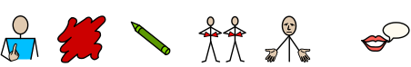
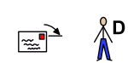 , .
.
,
,
.
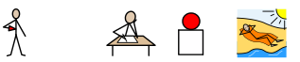
even
!
!
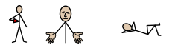
overworked
!
.

Above is an example of what you can draw for the Red Crayons letter.
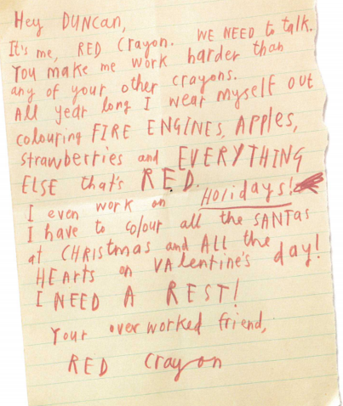

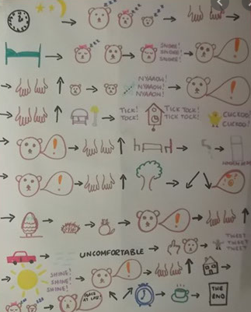
When you draw the text map it should be something like this.

(This is one for Goldilocks and the three bears).
The pictures will aid your child’s memory. Once they have memorised this style of text your child should eventually be able to adapt it for their own writing after learning the features of the text.
This should then be performed at the start of every English lesson so your child can repeatedly hear the structure of the text.

