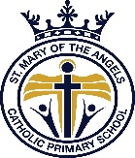
KS1 Home Learning Activities: Week beginning 30th March 2020
Physical Activity (PE)
Start you day with some physical activity. Try out Joe Wicks' PE lesson at 9am or perhaps have a go at some Zumba, dance or yoga.
Suggested websites:
https://www.youtube.com/thebodycoachtv
https://family.gonoodle.com/
https://imoves.com/imovement-signup

Maths:
This week we will be revising fractions at home with the help of White Rose Maths. Each day there will be a video to watch and a worksheet with activities to complete. You can do the activities straight in to your Home Learning books – no need to print the worksheet! Follow the link below to the website:
These lessons will be uploaded to our class page. All you have to do is click the link!
Monday: Lesson 1 – Recognise a third
Tuesday: Lesson 2 – Find a third
Wednesday: Lesson 3 – Unit fractions
Thursday: Lesson 4 – Non-unit fractions
Friday: Lesson 5 – Equivalence of a half and 2 quarters

Practice Maths skills on Mathletics (your log-in is glued in your Reading Records) or any of the suggested online maths game. Perhaps you could play a board game/maths game with a family member or help with the cooking (measuring/weighing). Don’t forget to complete the maths tasks in your Home Learning Packs.

English
This week in Key Stage One we are looking at letter writing. We thought it might be nice to write a letter to a chosen NHS staff member and thank them for all their hard work. You could choose a nurse, doctor, carer, porter or receptionist in the hospital. You can decide who you’d like to write to, if you’re not sure then ask a family member for some help.
Research the person you’d like to send a letter to. Perhaps, your aunt, uncle or neighbour works for the NHS. If so, then you could write a letter of thanks to them.
Each day we will upload some resources on our class pages to help you with your letter writing tasks.
We will start our letter writing process by writing a letter to a friend (informal letter). Then by Friday, we should be able to apply all the skills we’ve learnt and write a letter to a chosen NHS staff member.

Book Talk
Our comprehension task this week is a text all about the history of television.
Check our class page for this resource in the week
RE
Palm Sunday activity on Busy Things – Go to ‘My Assignments’​
Science
We will be furthering our knowledge of different animals and habitats – keep our eye out for the links we will post to MyUso.
Free Reading:
Read your own book each day for at least 20 mins. You can choose a book you have at home, an online book on Bug Club, a newspaper on First News or listen to an audio book on Audible if you would like to - https://stories.audible.com/start-listen
This week, we will be listening to a collection of stories called ‘Story Party’.

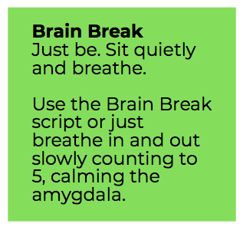
PSHE:
Mind Up – each day remember to complete 2-3 Brain Breaks for 2 mins each time. Give your brain a rest and focus on your breathing.
- This week we will be focusing on The Brain. Look at the activities below and choose some to complete this week.

