Take a look at the picture below…

Write the answers to the following questions in your books:
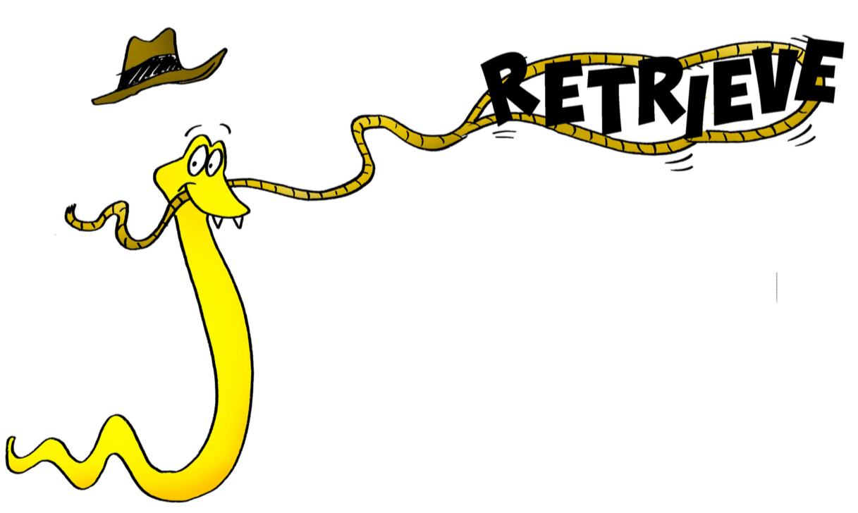

- What time of day is it in the picture?

- Why is only one tiger drinking from the puddle?

- Where will the tigers go once they have finished drinking?

- Think about where most tigers live. Research what the word captivity means through this web page: https://www.bbc.co.uk/teach/what-are-zoos-for/z649f4j

How do you feel about tigers that are kept in captivity?

