Dear Class F,
I need your help. This week, I heard you’re writing some letters. That sounds brilliant – I can’t wait to post them.
But there’s a problem. With all the wind and hail yesterday, one of my letters got wet in the rain. Can you help me to put the address in the right order? Otherwise I don’t know which letterbox to put it through! I’ve typed what I think is the address so it’s a bit clearer for you to help me. I’ve also included an example of another bit of my post to the Gingerbread Boy
so you can see what another letter looks like!
Good luck!
The Jolly Postman
W2 5PR
Shrewsbury Road
St Mary of the Angels School
Miss Percival
Bayswater

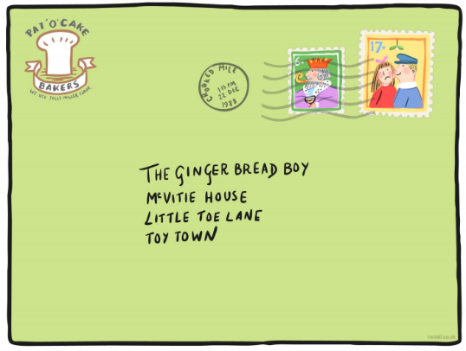
Now you’ve fixed my address, I have a challenge for you. Do you know your address? Can you write it below in the right order? Remember, proper nouns begin with a capital letter. Try to learn your address – it’s such an important thing to know!

